**25.1 Introduction**

Shared libraries, also known as shared objects or system libraries, are files that include the .so extension as part of their name. By placing code that is used by many programs into library files that can be shared, each program file can be smaller, the programs can use a more consistent base of code, and less disk space overall is consumed.

When a program is executed, the /lib/ld-linux.so dynamic linker will find and load the shared libraries needed by a program, prepare the program to execute, and then run it. Older binaries in the a.out format are linked and loaded by the /lib/ld.so program. Both programs will search for the libraries in the /lib directory, the /usr/lib directory, the directories listed in the LD_LIBRARY_PATH environment variable, and from the /etc/ld.so.cache cache file.

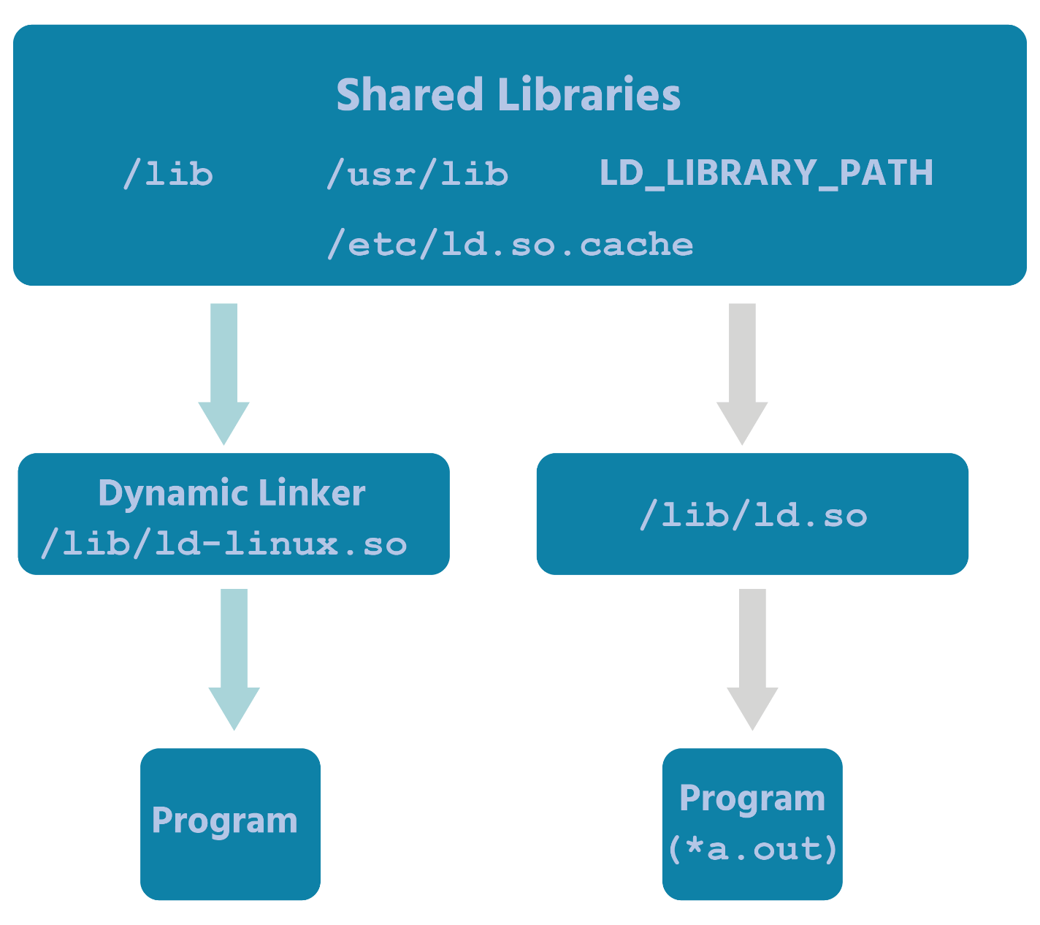

Managing shared libraries can be part of the management of the software of a system, especially if those libraries are placed in unusual locations within the filesystem. Library files that are located in the /lib or /usr/lib directories are normally configured to be automatically found by the programs that need them, but placing library files in other locations, such as the /usr/local/lib directory, may require configuring the system to be able to locate the shared libraries when needed.